# 

The Parish of St Andrew, Orford

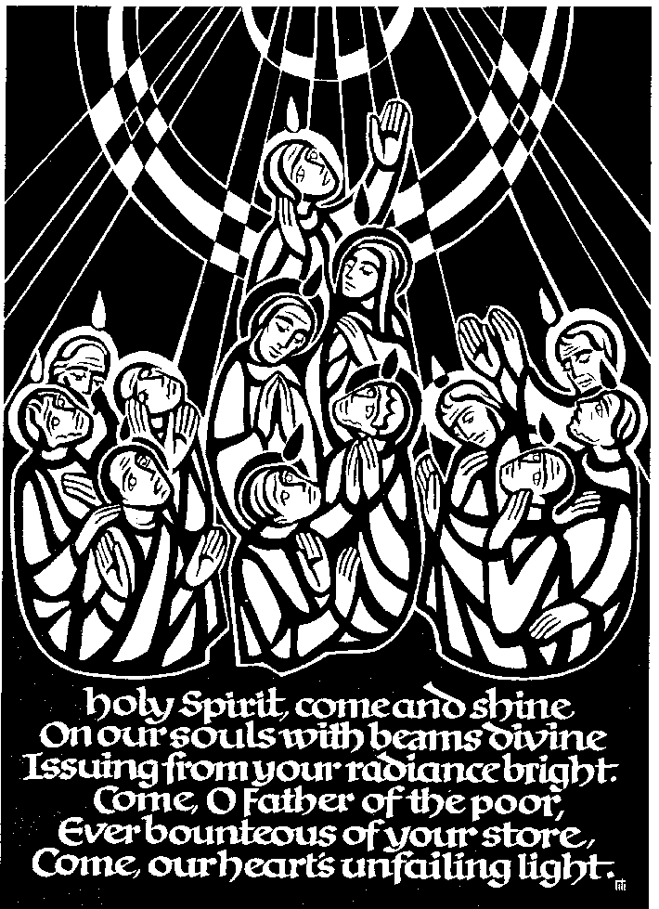

Baptism, confirmation

and holy communion

21st March 2018

Confirming bishop:

The Rt Reverend Richard Blackburn,

Bishop of Warrington

***On behalf of the congregation of St Andrew’s Church,***

***we wish you a very warm welcome.***

**Before the Service begins, please spend the time quietly in prayer.**

- Think of our Lord's promise to be with us whenever we meet

- Remember Bishop Richard, our confirming bishop and preacher;

- Pray for those to be confirmed

- Thank God for your own baptism and confirmation and ask him to walk with you on your journey in faith;

- If you’ve not been confirmed, consider whether this might be the right time for you. Have a word with the vicar afterwards.

# *There will be an opportunity for photographs at the end of the service during the final hymn when the newly confirmed have each received their candle. Photographs are not permitted at any other point during the service.*

Following the NOTICES, there will be a period of **silence.** You might like to use it to say the following prayer:

Almighty God,

to whom all hearts are open,

all desires known,

and from whom no secrets are hidden:

cleanse the thoughts of our hearts

by the inspiration of your Holy Spirit,

that we may perfectly love you,

and worthily magnify your holy name;

through Christ our Lord. Amen.

# *Order of Service*

## PREPARATION

**Introit hymn:** ‘From heaven you came’

*(please stand)*

From heaven you came, helpless babe,

Entered our world, your glory veiled;

Not to be served, but to serve

And give your life, that we might live.

*This is our God, the Servant King,*

*He calls us now to follow him,*

*To bring our lives as a daily offering*

*of worship to the Servant King.*

There in the garden of tears,

My heavy load he chose to bear;

His heart with sorrow was torn,

“Yet not my will but yours,” he said.

*This is our God, the Servant King,*

Come see his hands and his feet,

The scars that speak of sacrifice,

Hands that flung stars into space

To cruel nails surrendered.

*This is our God, the Servant King,*

So let us learn how to serve,

And in our lives enthrone him;

Each other’s needs to prefer,

For it is Christ we're serving.

*This is our God, the Servant King,*

*The bishop introduces the service.*

### GREETING

Bishop: Blessed be God, Father, Son and Holy Spirit.

All: Blessed be his kingdom, now and for ever. Amen.

Bishop: There is one body and one spirit.

All: There is one hope to which we were called;

Bishop: one Lord, one faith, one baptism,

All: one God and Father of all.

Bishop: Peace be with you.

All: And also with you.

### THE COLLECT

Bishop: Let us pray …

[following a period of silence]

Heavenly Father, by the power of your Holy Spirit

you give to your faithful people

new life in the water of baptism.

Guide and strengthen us by the same Spirit,

that we who are born again may serve you in faith and love,

and grow into the full stature of your Son, Jesus Christ,

who is alive and reigns with you

in the unity of the Holy Spirit,

now and for ever. Amen

### THE GOSPEL

(Please turn to face the place where the gospel is read)

Priest The Lord is a great God, O that today you would listen to his voice. harden not your hearts.

All: Praise to you O Christ, King of eternal glory.

Hear the Gospel of our Lord Jesus Christ according to John*(Jn 8. 21-30)*

All: Glory to you, O Lord

Again he said to them, ‘I am going away, and you will search for me, but you will die in your sin. Where I am going, you cannot come.’ Then the Jews said, ‘Is he going to kill himself? Is that what he means by saying, “Where I am going, you cannot come”?’ He said to them, ‘You are from below, I am from above; you are of this world, I am not of this world. I told you that you would die in your sins, for you will die in your sins unless you believe that I am he.’ They said to him, ‘Who are you?’ Jesus said to them, ‘Why do I speak to you at all? I have much to say about you and much to condemn; but the one who sent me is true, and I declare to the world what I have heard from him.’ They did not understand that he was speaking to them about the Father. So Jesus said, ‘When you have lifted up the Son of Man, then you will realize that I am he, and that I do nothing on my own, but I speak these things as the Father instructed me. And the one who sent me is with me; he has not left me alone, for I always do what is pleasing to him.’ As he was saying these things, many believed in him.

This is the Gospel of the Lord

All: Praise to you, O Christ

**SERMON:** The Rt Rev. Richard Blackburn, Bishop of Warrington

**Hymn:** ‘Be still, for the presence of the Lord’

*(the congregation sit or kneel to sing)*

Be still, for the presence of the Lord, the Holy One is here;

Come bow before him now with reverence and fear.

In Him no sin is found, we stand on holy ground;

Be still, for the presence of the Lord, the Holy One is here.

Be still, for the glory of the Lord, is shining all around;

He burns with holy fire; with splendour He is crowned.

How awesome is the sight, our radiant King of light;

Be still, for the glory of the Lord, is shining all around.

Be still, for the power of the Lord is moving in this place;

He comes to cleanse and heal, to minister His grace.

No work too hard for Him, in faith receive from Him;

Be still, for the power of the Lord is moving in this place.

## LITURGY OF INITIATION

PRESENTATION OF THE CANDIDATES

*Each parish priest presents their candidates in turn. The candidates stand when they are presented and then move to the front of church.*

Reverend Father in God, I present ... to be confirmed within the Church of God.

The candidates for baptism and confirmation stand before the bishop.

The bishop asks the candidate for baptism:

Bishop: Georgia, do you wish to be baptized?

Georgia: I do.

The bishop asks the candidates for confirmation who have been baptized:

Bishop: Have you been baptized in the name of the Father, and of the Son, and of the Holy Spirit?

Candidates: I have.

The bishop asks all the candidates

Bishop: Are you ready with your own mouth and from your own heart to affirm your faith in Jesus Christ?

Candidates: I am.

The bishop addresses the whole congregation:

Bishop: People of God, will you welcome these candidates and

uphold them in their life in Christ?

All: With the help of God, we will.

### DECISION

The Paschal candle is lit. The bishop then addresses the candidates:

Bishop: To follow Christ means dying to sin and rising to new life with him. Therefore I ask:

Bishop: Do you reject the devil and all rebellion against God?

All: I reject them.

Bishop: Do you renounce the deceit and corruption of evil?

All: I renounce them.

Bishop: Do you repent of the sins that separate us from God and neighbour?

All: I repent of them.

Bishop: Do you turn to Christ as Saviour?

All: I turn to Christ.

Bishop: Do you submit to Christ as Lord?

All: I submit to Christ.

Bishop: Do you come to Christ, the way, the truth and the life?

All: I come to Christ.

### SIGNING WITH THE CROSS

The bishop makes the sign of the cross on the forehead of the candidate for baptism, saying:

Bishop: Georgia Mae, Christ claims you for his own.  
Receive the sign of his cross.

When the candidate for baptism has been signed, the bishop says to her:

Bishop: Do not be ashamed to confess the faith of Christ crucified.

All: Fight valiantly as a disciple of Christ  
against sin, the world and the devil,  
and remain faithful to Christ to the end of your life.

Bishop: May almighty God

deliver you from the powers of darkness,  
restore in you the image of his glory,  
and lead you in the light and obedience of Christ. **Amen.**

### PRAYER OVER THE WATER

The ministers and candidate for baptism, together with candidates for confirmation gather at the baptismal font. Please stand.

Bishop: Praise God who made heaven and earth,

All: who keeps his promise for ever.

Bishop: Let us give thanks to the Lord our God.

All: It is right to give him thanks and praise.

Bishop: We thank you, almighty God, for the gift of water

to sustain, refresh and cleanse all life.

Over water, the Holy Spirit moved

in the beginning of creation.

Through water you led the children of Israel

from slavery in Egypt to freedom in the promised land.

In water your Son Jesus received the Holy Spirit

as the Messiah, the Christ,

to lead us from the death of sin to newness of life.

We thank you, Father, for the water of baptism.

In it, we are buried with Christ in his death.

By it we share in his resurrection.

Through it we are reborn by the Holy Spirit.

Therefore, in joyful obedience to your Son,

we baptize into his fellowship

those who come to him in faith.

Now sanctify this water that,

by the power of your Holy Spirit,  
they may be cleansed from sin and born again.  
Renewed in your image,

may they walk by the light of faith

and continue for ever

in the risen life of Jesus Christ our Lord;

to whom with you and the Holy Spirit  
be all honour and glory,

now and for ever. **Amen.**

### PROFESSION OF FAITH *(please stand)*

The bishop addresses the congregation

Brothers and sisters, I ask you to profess  
together with these candidatesthe faith of the Church.

Bishop: Do you believe and trust in God the Father?

All: I believe in God, the Father almighty,  
creator of heaven and earth.

Bishop: Do you believe and trust in his Son Jesus Christ?

All: I believe in Jesus Christ, his only Son, our Lord,  
who was conceived by the Holy Spirit,  
born of the Virgin Mary,  
suffered under Pontius Pilate,  
was crucified, died, and was buried;  
he descended to the dead.  
On the third day he rose again;  
he ascended into heaven;  
he is seated at the right hand of the Father,  
and he will come again to judge the living and the dead.

Bishop: Do you believe and trust in the Holy Spirit?

All: I believe in the Holy Spirit,  
the holy catholic Church,  
the communion of saints,  
the forgiveness of sins,  
the resurrection of the body,

and the life everlasting. Amen.

### BAPTISM

Georgia’s family and godparents stand as the bishop pours water on the candidate, saying

Bishop: Georgia, I baptize you  
in the name of the Father, and of the Son, and of the Holy Spirit. Amen.

Bishop: May God, who has received you by baptism

into his Church,  
pour upon you the riches of his grace;  
that within the company of Christ’s pilgrim people,  
you may daily be renewed by his anointing Spirit,  
and come to the inheritance of the saints in glory. **Amen.**

Bishop: Almighty God,  
we thank you for our fellowship in the household of faith  
with all who have been baptized into your name.  
Keep us faithful to our baptism,  
and so make us ready for that day  
when the whole creation shall be made perfect in your Son,  
our Saviour Jesus Christ. **Amen.**

The bishop and the candidates gather at the place of confirmation.

The candidates are sprinkled by the Bishop.

Then the bishop says:

Bishop: Almighty God,

we thank you for our fellowship in the household of faith

with all who have been baptized in your name.

Keep us faithful to our baptism,

and so make us ready for that day

when the whole creation shall be made perfect in your Son,

our Saviour Jesus Christ. **Amen**

## CONFIRMATION

The bishop stands before those who are to be confirmed, and says:

Bishop: Our help is in the name of the Lord

All: who has made heaven and earth.

Bishop: Blessed be the name of the Lord

All: now and for ever. Amen.

The bishop extends his hands towards those to be confirmed and says:

Bishop: Almighty and ever-living God,  
you have given these your servants new birth  
in baptism by water and the Spirit,  
and have forgiven them all their sins.  
Let your Holy Spirit rest upon them:  
the Spirit of wisdom and understanding;  
the Spirit of counsel and inward strength;  
the Spirit of knowledge and true godliness;  
and let their delight be in the fear of the Lord. **Amen**.

The bishop confirms each candidate by name, and then anoints them. Family and friends are invited to stand as a mark of support for their candidate(s):

Bishop: *N.*, God has called you by name and made you his own.

Confirm, O Lord, your servant with your Holy Spirit. **Amen**.

The bishop then invites the congregation to pray for all those on whom hands have been laid using the following prayer:

All: Defend, O Lord, these your servants

with your heavenly grace,

that they may continue yours for ever,

and daily increase in your Holy Spirit more and more  
until they come to your everlasting kingdom.

Amen.

## THE PEACE *(please stand)*

Bishop: God has made us one in Christ.  
He has set his seal upon us  
and, as a pledge of what is to come,  
has given the Spirit to dwell in our hearts.

The peace of the Lord be always with you.

All: And also with you.

Bishop: Let us offer one another a sign of peace.

Everyone is invited to share the peace with one another.

## LITURGY OF THE EUCHARIST

## THE OFFERTORY

*‘This Collection will be given to Ordinands and their families in training in the Diocese with 10% given to support the links between our diocese and others across the world'.*

**Offertory hymn:** ‘O Jesus I have promised’

O Jesus, I have promised to serve thee to the end;

be thou for ever near me, my Master and my Friend:

I shall not fear the battle if thou art by my side,

nor wander from the pathway if thou wilt be my guide.

O let me feel thee near me: the world is ever near;

I see the sights that dazzle, the tempting sounds I hear;

my foes are ever near me, around me and within;

but, Jesus, draw thou nearer, and shield my soul from sin.

O let me hear thee speaking in accents clear and still,

above the storms of passion, the murmurs of self-will;

O speak to reassure me, to hasten or control;

O speak, and make me listen, thou guardian of my soul.

O Jesus, thou hast promised to all who follow thee,

that where thou art in glory there shall thy servant be;

and, Jesus, I have promised to serve thee to the end:

O give me grace to follow, my Master and my Friend.

O let me see thy foot-marks, and in them plant mine own;

my hope to follow duly is in thy strength alone:

O guide me, call me, draw me, uphold me to the end;

and then in heaven receive me, my Saviour and my Friend

Eucharistic Prayer H *(please kneel)*

Bishop The Lord is here

**All His Spirit is with us**

Bishop Lift up your hearts

**All We lift them to the Lord**

Bishop Let us give thanks to the Lord our God

**All It is right to give thanks and praise**

Bishop It is right to praise you, Father, Lord of all creation; in your love you made us for yourself. When we turned away you did not reject us, but came to meet us in your Son.

**All You embraced us as your children and welcomed us to sit and eat with you.**

Bishop In Christ you shared our life that we might live in him and he in us.

**All He opened his arms of love upon the cross and made for all the perfect sacrifice for sin.**

Bishop On the night he was betrayed, at supper with his friends he took bread, and gave you thanks; he broke it and gave it to them, saying: Take, eat; this is my body which is given for you; do this in remembrance of me.

**All Father, we do this in remembrance of him: his body is the bread of life.**

Bishop At the end of supper, taking the cup of wine, he gave you thanks, and said: Drink this, all of you; this is my blood of the new covenant, which is shed for you for the forgiveness of sins; do this in remembrance of me.

**All Father, we do this in remembrance of him: his blood is shed for all.**

Bishop As we proclaim his death and celebrate his rising in glory, send your Holy Spirit that this bread and this wine, may be to us the body and blood of your dear Son.

**All As we eat and drink these holy gifts make us one in Christ, our risen Lord**

Bishop With your whole Church throughout the world we offer you this sacrifice of praise and lift our voice to join the eternal song of heaven:

**All Holy, holy, holy Lord, God of power and might, Heaven and earth are full of your glory. Hosanna in the highest.**

Bishop: Trusting in the compassion of God, let us pray with confidence as our Saviour has taught us:

All: Our Father, who art in heaven,

hallowed be thy name,

Thy kingdom come, thy will be done,

on earth, as it is in heaven.

Give us this day our daily bread,

and forgive us our trespasses,

as we forgive those who trespass against us.

And lead us not into temptation,

but deliver us from evil.

For thine is the kingdom, the power and the glory,

for ever and ever. Amen.

Bishop: We break this bread to share in the body of Christ.

All: Though we are many, we are one body,

because we all share in one bread.

All: Lamb of God, you take away the sins of the world:

have mercy upon us.

Lamb of God, you take away the sins of the world:

have mercy upon us.

Lamb of God, you take away the sins of the world:

grant us peace.

Bishop: Jesus is the Lamb of God,

who takes away the sins of the world.

Blessed are those who are called to his supper.

All: Lord, I am not worthy to receive you,

but only say the word, and I shall be healed.

Holy Communion is administered at the front of Church - please follow the directions of the wardens. The newly confirmed are invited to receive first.

**Everyone** is warmly invited to come to the altar, and those in good standing within their Church are invited to receive the sacrament. Those who prefer to receive a blessing are invited to come forward at the same time. Please indicate **clearly** if you wish to receive a blessing by bowing your head and keeping your hands well tucked in. Communion will be distributed at the high altar and in the Lady Chapel – please follow the directions of the sides people.

During the distribution of the sacrament, the following hymns are sung:

There is a Redeemer, Jesus, God’s own Son,

Precious Lamb of God, Messiah, Holy One.

*Thank you, O my Father, for giving us your Son,*

*And leaving your Spirit till the work on earth is done.*

Jesus, my Redeemer, name above all names,

Precious Lamb of God, Messiah, O for sinners slain.

When I stand in glory, I will see his face,

And there I’ll serve my King for ever, in that holy place.

I, the Lord of sea and sky I have heard my people cry.

All who dwell in dark and sin my hand will save.

I who made the stars of night, I will make their darkness bright.

Who will bear my light to them?

Whom shall I send?

*Here I am, Lord. Is it I Lord?*

*I have heard you calling in the night.*

*I will go Lord, if you lead me.*

*I will hold your people in my heart.*

I the Lord of snow and rain, I have borne my people’s pain.

I have wept for love of them - they turn away.

I will break their hearts of stone, give them hearts for love alone.

I will speak my word to them.

Whom shall I send?

*Here I am, Lord*…

I, the Lord of wind and flame, I will tend the poor and lame.

I will set a feast for them. my hand will save.

Finest bread I will provide till their hearts are satisfied.

I will give my life to them.

Whom shall I send?

*Here I am, Lord*…

### PRAYER AFTER COMMUNION

Bishop: Let us pray:

**All: Father of all, we give you thanks and praise, that when we were still far off you met us in your Son and brought us home. Dying and living he declared your love, gave us grace and opened the gate of glory. May we who share Christ’s body live his risen life; we who drink his cup bring life to others; we whom the Spirit lights give light to the world. Keep us firm in the hope you have set before us, so we and all your children shall be free, and the whole earth live to praise your name; through Christ our Lord. Amen**

## SENDING OUT

The congregation remain kneeling:

Bishop: The God of all grace, who called you to his eternal glory in Christ Jesus, establish, strengthen and settle you in the faith; and the blessing of God almighty, the Father, the Son and the Holy Spirit, be upon you and remain with you always. **Amen.**

**Final hymn:**

As the hymn is sung, the newly confirmed gather on the sanctuary steps. The bishop gives all the candidates a lighted candle, lit from the Paschal candle.

I danced in the morning when the world was begun,

and I danced in the moon and the stars and the sun,

and I came down from heaven and I danced on the earth;

at Bethlehem I had my birth.

*Dance, then, wherever you may be;*

*I am the Lord of the dance, said he,*

*and I’ll lead you all wherever you may be,*

*and I’ll lead you all in the Dance, said he.*

I danced for the scribe and the Pharisee,

but they would not dance and they wouldn’t follow me.

I danced for the fishermen, for James and John;

they came with me and the Dance went on:

*Dance, then, wherever you may be…*

I danced on the Sabbath and I cured the lame;

the holy people said it was a shame.

They whipped and they stripped and they hung me on high,

and they left me there on a cross to die.

*Dance, then, wherever you may be…*

I danced on a Friday when the sky turned black;

it’s hard to dance with the devil on your back.

They buried my body and they thought I’d gone;

but I am the Dance and I still go on.

*Dance, then, wherever you may be…*

They cut me down and I leapt up high;

I am the life that will never, never die;

I’ll live in your if you’ll live in me:

I am the Lord of the Dance, said he:

*Dance, then, wherever you may be…*

As the hymn finishes, the bishop says

Bishop: God has delivered us from the dominion of darkness  
and has given us a place with the saints in light.

You have received the light of Christ;  
walk in this light all the days of your life.

All: Shine as a light in the world  
to the glory of God the Father.

### DISMISSAL

Bishop: Go in the light and peace of Christ.

All: Thanks be to God.

 The bishop leads the newly confirmed out of church into the world.

_______________________________________________________________

*Material from *Common Worship: Calendar, Lectionary and Collects (Church House Publishing, 1997); *Common Worship: Initiation Services (Church House Publishing, 1999); Common Worship: Services and Prayers for the Church of England (Church House Publishing, 2000) is copyright © The Archbishops' Council of the Church of England. Hymns are reproduced under CCLI licence No. 2101652*